**Practical No. 7**

**Exercise - Create an application using Filters (uppercase,lowercase,filter filter, orderby)**

**Implementation:**

**Program:**

<!DOCTYPE html>

<html lang="en">

<head>

  <meta charset="UTF-8">

  <meta name="viewport" content="width=device-width, initial-scale=1.0">

  <title>AngularJS Example</title>

  <!-- Include AngularJS library -->

  <script src="https://ajax.googleapis.com/ajax/libs/angularjs/1.8.2/angular.min.js"></script>

</head>

<body>

<!-- AngularJS application and controller for the first example -->

<div ng-app="">

  <!-- Input field for entering a name -->

  <input type="text" ng-model="name" placeholder="Enter Your Name"><br>

  <!-- Display the uppercase version of the entered name -->

  <h1>Output: {{name | uppercase}}</h1>

  <!-- Display the lowercase version of the entered name -->

  <h1>Output: {{name | lowercase}}</h1><br>

  <!-- Input field and output for currency formatting -->

    <input type="text" ng-model="amount" placeholder="Enter Amount"><br>

    <h1>Output: {{amount | currency}}</h1><br>

</div>

</body>

</html>

**Output:**

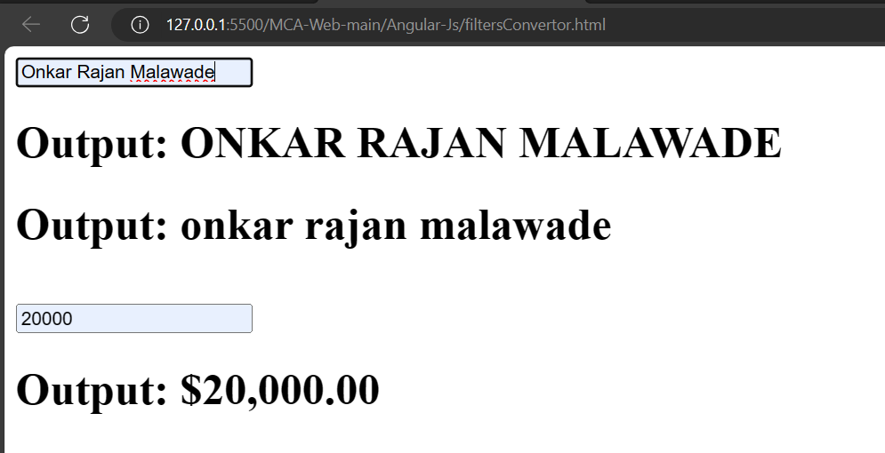

**Program:**

<!DOCTYPE html>

<html lang="en">

<head>

    <!-- Define the character set and viewport settings for the document -->

    <meta charset="UTF-8">

    <meta name="viewport" content="width=device-width, initial-scale=1.0">

    <!-- Include the AngularJS library -->

    <script src="https://ajax.googleapis.com/ajax/libs/angularjs/1.6.9/angular.min.js"></script>

    <!-- Set the title of the document -->

    <title>Document</title>

</head>

<body>

    <!-- Introduction text -->

    <p>

        Click on the Headers of the Table to sort them.

    </p>

    <!-- AngularJS application and controller -->

    <div ng-app="ap1" ng-controller="ctr1">

        <!-- Table with headers and dynamic data binding -->

        <table border="2px solid black" width="100%">

            <!-- Table headers with ng-click to trigger sorting -->

            <tr>

                <th ng-click="orderByMe('name')">Name</th>

                <th ng-click="orderByMe('city')">City</th>

            </tr>

            <!-- Table rows with ng-repeat to iterate over data and orderBy filter for sorting -->

            <tr ng-repeat="x in names | orderBy:myOrderBy">

                <!-- Displaying data in each cell -->

                <td> {{x.name}} </td>

                <td> {{x.city}} </td>

            </tr>

        </table>

    </div>

    <!-- AngularJS script to define the module, controller, and data -->

    <script>

        angular.module('ap1', []).controller('ctr1', ($scope) => {

            // Sample data for the table

            $scope.names = [{

                name: 'Onkar',

                city: 'USA'

            }, {

                name: 'Atharav',

                city: 'Dubai'

            }, {

                name: 'Raju',

                city: 'Ulhasnagar'

            }, {

                name: 'Rahul',

                city: 'Phonda'

            }, {

                name: 'Suresh',

                city: 'Goa'

            }, {

                name: 'Naresh',

                city: 'Uk'

            }, {

                name: 'Ramesh',

                city: 'UP'

            }, {

                name: 'Paresh',

                city: 'Nagaland'

            }, {

                name: 'Jignesh',

                city: 'Pune'

            }];

            // Function to set the sorting order

            $scope.orderByMe = function (x) {

                $scope.myOrderBy = x;

            }

        });

    </script>

</body>

</html>

**Output:**

